EXPERIMENT 1

ER DIAGRAM OF COLLEGE DATABASE

**Aim:** Draw an ER diagram of a college database.

**Components of an ER Diagram:**

Entity: Object that is relevant to given system. Represented as rectangle.

Attribute: Trait of an entity, relationship or other attribute. Represented as oval.

Derived Attribute: Attribute derived from another attribute. Represented as dotted ovals.

Multivalued Attribute: Attributes that have more than one value. Represented as double ovals.

Relationship: Describes how entities interact. Represented as rhombus.

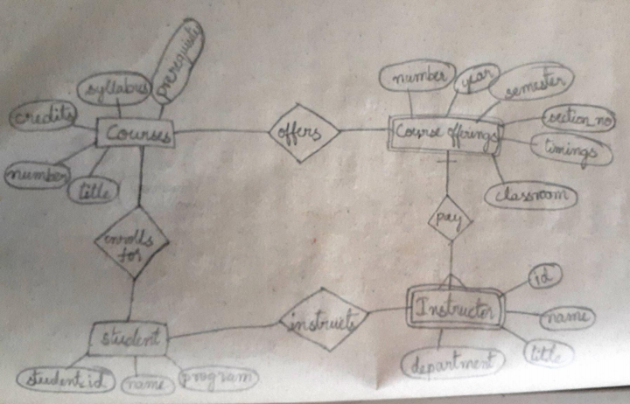

**ER Diagram:**

